Customer Demand Signal Service Blueprint

(Need to agree upon a name for the solution)

Meeting New Market Demands

Insert piece from PwC Retail Point of View (need to obtain working document)

Propagation of a real-time Consumer Demand Signal Service (CDSS) throughout the supply chain will have far reaching impact on the Retail and Consumer Packaged Goods industries. Retailers and Suppliers will able to “better optimize, plan, and execute decisions, while improving the efficiency and utilization of their existing resources”. The CDSS partnership developed between Microsoft, Intel and PWC Consulting will address the challenge of responding to consumer demand in real-time by focusing on the following goals:

- Implement standards that will allow decision support information to freely flow between the participants in the supply chain
- Reduce the time it takes for the demand signal to propagate throughout the supply chain.
- Redefine planning processes to base forecasts on consumer demand, allowing for optimization of the ordering and manufacturing processes with as little human intervention as possible.
- Develop solutions that will scale to support the supply chain functions of the largest retailers and manufacturers in the world, to the smallest “mom & pop” retail outlet.

The Business Challenge

Most participants in the supply chain today rely on forecasts of consumer demand rather than actual consumer demand to schedule and drive their individual activities. Because these activities often occur within silos, response to actual consumer demand is difficult to match and even more difficult to optimize. The resulting overall supply chain is not synchronized to consumer demand and in its current form, prevents the real-time flow of information to the supply chain partners, and adversely affects product replenishment flow to consumers.

To insure themselves against adverse consumer replenishment situations, suppliers, manufacturers and retailers have created extensive buffers of distribution centers and warehouses. These huge safety nets are by their essence inefficient because they consume enormous amounts of capital resources. Still with these investments in buffers, the consumer still experiences an inordinate amount of out-of-stock situations at the point of purchase. This is a lost revenue opportunity anytime consumers are unable to purchase product that is in the supply-chain, or worse yet not manufactured.

The Solution Overview

The Consumer Demand Signal Service relies on the Data Ventures' XPLOSS algorithms to learn normal item velocities and detect statistical variances from these such as "moving too fast", "moving to slow", "new item", "dropped item", and out of stock (OOS). XPLOSS learns best from minute-by-minute transaction data containing the details of what items were observed and at what price for every transaction. In the supermarket context, a transaction is a "shopping basket checkout", and observations are UPCs or item codes scanned by the checker. For every transaction, the data includes at least a time stamp, a series of items identified by UPCs or item codes, the item quantities, and the net price of each item or the regular price plus applicable discounts.

Training of the XPLOSS algorithm yields a model of item velocity for each monitored item at each monitored store under various merchandising conditions. The XPLOSS algorithm does this by transforming historical item movement data (across 1 or more stores) into a series of "event observations" whose arrival times behave in a random, statistically independent Poisson process. The XPLOSS model accounts for current price, time of day and day of week, store name and current store traffic, current promotions, in-store competition, and seasonality. When the model is first trained, it is used to detect OOS, new item, and dropped item events. These events are then used to "adjust" the historical data, which the model retrains to improve its accuracy. The model is automatically rebuilt every 15 minutes to 24 hours, depending on the specific installation.

New transaction data is fed to the XPLOSS model to answer the question "What is the probability of the newly observed transaction data given the normal velocity model?" (Note that "normal velocity" takes into account current conditions such as price, promotion, traffic, etc.) If there is a small probability of the data being what it is or more extreme (e.g., slower/faster sales), then an anomaly event is generated. The kind of event (new item, dropped item, OOS, fast, slow) depends on the transaction data and model rules. These rules are adapted for specific installations. Events are immediately stored into the events cache so they can be accessed by the events server. Certain velocity model details, such as expected item velocities and historical item sales are put into the cache as well.

The item movement, velocity, and event cache contents can be accessed at any time via a client connection to the cache server. Either an XML or HTML client currently makes these connections. The server supports detailed reporting (e.g., individual events or item velocities, most recent item sale) and summarization (e.g., service level over the past month, current OOS event losses exceed some threshold, observed item velocity over the past day). The cache is normally updated every 15 minutes. The DV/P&G Item Velocity Monitor consists of:

- A data feed (for trickled TLOGs and daily Item Tables)
- Data handlers (RCO, POS_DATASOURCE, XPDATAREADER, XPIVMDBWRITE)
- A high-speed, compressed transaction database (XPDB, XPSORT)
- A velocity monitoring and out of stock (OOS) detection algorithm (XPLOSS)
- An item movement and velocity/OOS events cache and server (IVMSERVER)
- A web server (http daemon)
- An HTML events formatter (CGI bin IVMCLIENT)
- An XML events formatter (notification client IVMALERT)
- A processing scheduler (cron)
- A batch process script (IVMDRIVER)
- A messaging server (BizTalk)

Technology

ASPEN (Application Service Provided Enterprise Notification System) is a centrally hosted Web Service that contains the Consumer Demand Signal Monitor algorithm. ASPEN can accept data from enterprise retail organizations of all sizes and scale.

Retail enterprise customers send Point of Sale (POS) transaction data to a central BizTalk Server Group. BizTalk constructs the data to be sent to the Demand Signal Monitor. The Demand Signal Monitor determines what products are out of stock based on the POS data from the store and sends a message back to the BizTalk Server Group. BizTalk derives the destination, source, and message type from the data contained in the message from the Monitor. A message is then routed to a stock person working at the store where the POS data originated.

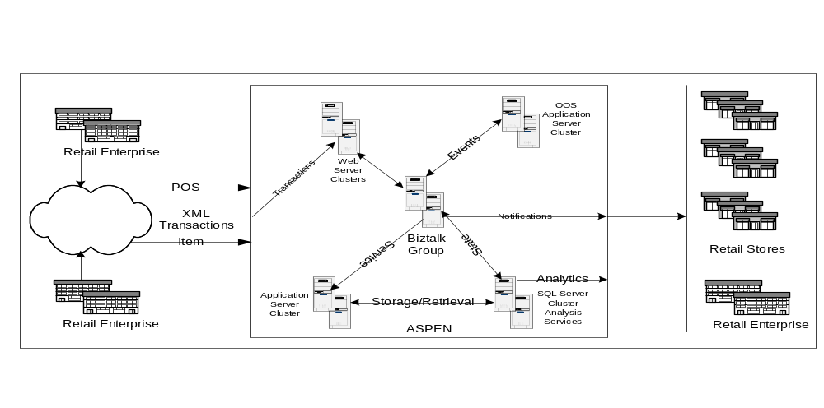

Anatomy
ASPEN is a hosted web service environment. Its primary function is to deliver the consumer demand signal (OOS notification) for the retail enterprise customer. It consists of a multi-server web cluster as shown in the diagram.

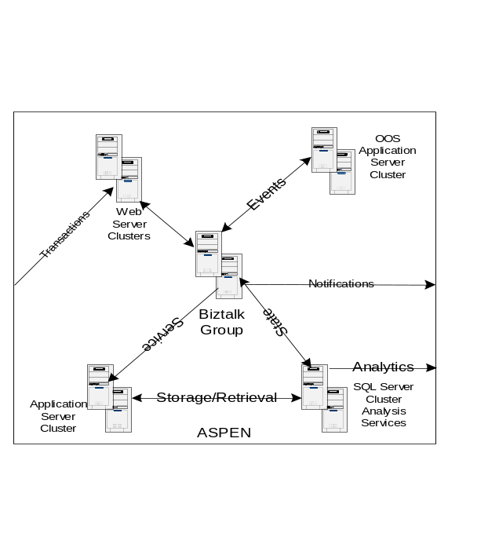
Windows 2000 Advanced Server Web Cluster
Provide all HTTP and HTTPS connectivity. This cluster serves as the interface to the BizTalk Server Group through ASP driven HTTPS Receive Functions. The customer has the ability to VPN into our Web Cluster and use FTP. This cluster will also contain the Web Interface for managing access to Demand Signal Notification Services.

BizTalk Server Group Cluster
Provides all message and data routing for ASPEN. Open Channels and Message ports are used to derive transport and destination information from data contained in the incoming XML data from the Enterprise Retailer. The transport and destination information are derived from a SQL Server 2000 database.

Rational for using Open Message Ports and Channels:
“When you create a channel for an open messaging port, and the destination information is provided in the document, the inbound document definition for that channel must reference a specification that is properly configured.

You can use an open messaging port to send one or more standardized documents to many different current or future trading partner organizations without creating a messaging port for each destination. All documents share the same envelope, security, and transport properties that are established in the messaging port.”

Application Server Cluster
The Application Servers contain the Business objects required for the Demand Signal Notification System. As well as COM+ objects for the Web Interface.

SQL Server / Analysis Services Cluster
The SQL Server Cluster will contain the BizTalk databases for managing state. It could also act as a repository for POS and Item promotion data into a data warehouse based on the ARTS data model fed by the IXRetail XML data model definitions. Retail specific Business Intelligence Cubes would then be generated sold as a Web Service to the Enterprise Retail Customer.

OOS Application Server Cluster
This cluster of servers contains the Data Ventures Demand Signal Algorithm for determining what items are out of stock for a store given POS and Item History. Point of Sale data will be sent to this algorithm to be processed to determine what is out of stock at that store. Then a message will be routed back to BizTalk to be sent back to SMTP pagers.

Solution Benefits

There are several key benefits for supply chain participants, one is to reduce the rate of “Out of Stocks” at the point of purchase to near zero. This is a huge incentive for retailers and in turn for manufacturers. Another expected benefit is that participants in the supply chain may be able to reduce stockpiles by 50 %. The ramifications of this occurring in the supply chain are staggering. If participants could reduce capital investment in inventory, warehousing and manual processes, they could save huge sums of money while improving product availability and providing an ehnaced shopping experience to the end cosnumer. Some of the perceived benfits for Retailers andSuppliers are listed below:

Retailer Benefits

- Improve staff utilization
- Improve staff utilization
- Improve margin
- Increase sales
- Increase stock turns
- Reduce inventory

- Decrease out of stocks

Supplier Benefits:
- Increase sales
- Improve profitability
- Improve brand loyalty
- Reduce inventory

Functional Business Concept

The Consumer Demand Signal Service detects out of stock conditions in a live store environment and notifies store personnel of these issues. The service is driven by near real-time data feeds of the store's transaction data. This movement and pricing data is supplemented by item and promotional data feeds. A subscription service manages delivery of the events and alarms to the users. There are two functional domains of this offering:

Retail Integration & Operations Services (RIO)
RIO integrates the retail enterprise and its data into Consumer Demand Signal Service. RIO is broken into two subsystems: RIO Inputs and RIO Outputs.
- RIO Inputs focuses on integrating Point of Sale, item, and promotion batched data into the hosted ASPEN service via secured XML data transfers over HTTPS or VPN connections.
- RIO Outputs focuses on message routing to the endpoint devices and systems supported by Consumer Demand Signal Service. RIO Outputs currently supports Motorola, Blackberry, and other SMTP pager devices only. Future versions of this offering will support Symbol’s Retail Commercial Infrastructure Systems. Both Motorola and Blackberry devices were used in the offering pilots at Meijer and Food Lion.

Application Service Provided Enterprise Notification System (ASPEN)
ASPEN is a hosted application service that is responsible for accepting RIO Inputs, sending them to the out of stock Notification algorithm for processing, and accepting and routing outbound messages as a result of that processing to RIO Output Devices, Web Services, and Retail Commercial Systems. ASPEN is an application service; it is constructed to support multiple retail enterprises with thousands of retail grocery stores and data. A web service, ASPEN Slopes, is designed to maintain retail, store, user, device, and subscription data as well as provide the required accounting and operational facilities for managing the business of the Consumer Demand Signal Service.

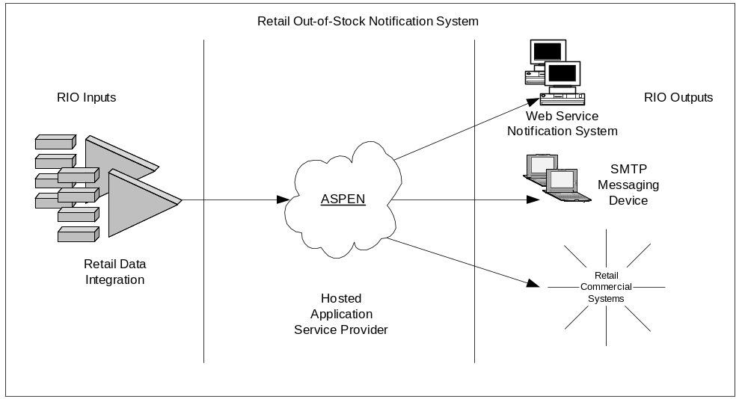

User Experience

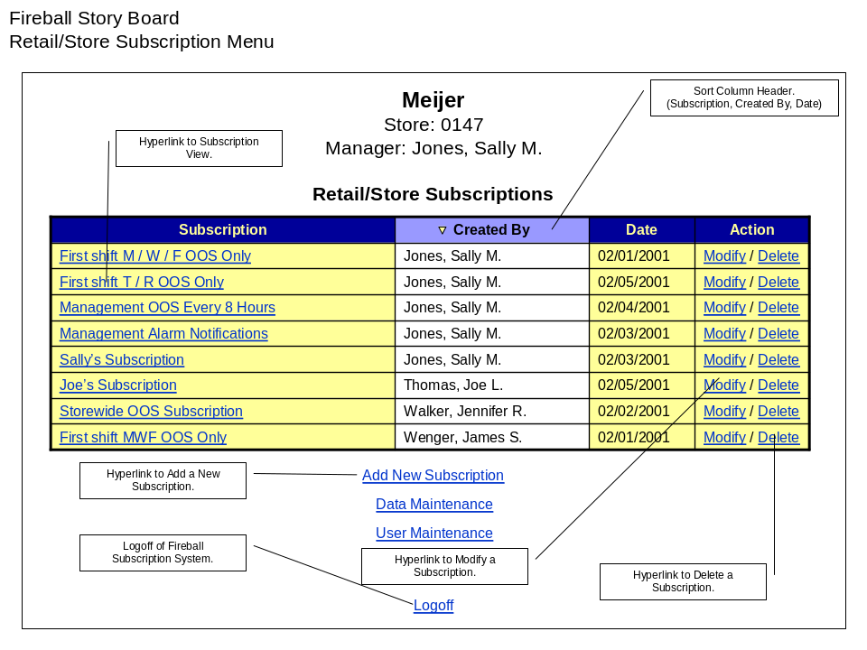
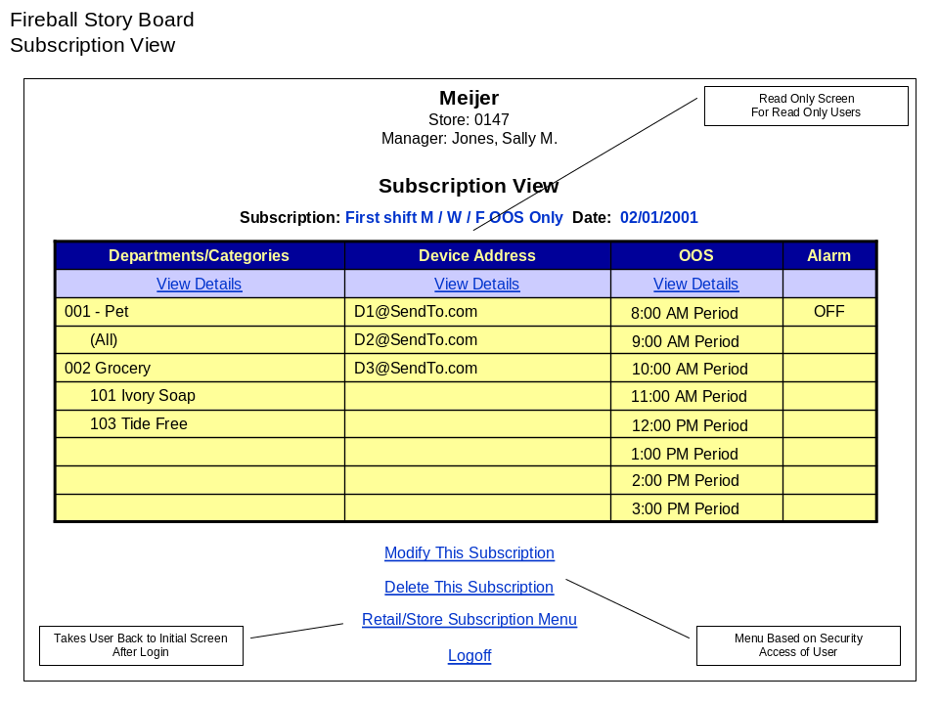
These section would be replaced with the actual screen shots of subscription management pages and some the messages being delivered to wireless devices.

Software Architecture

System Architecture

For More Information

